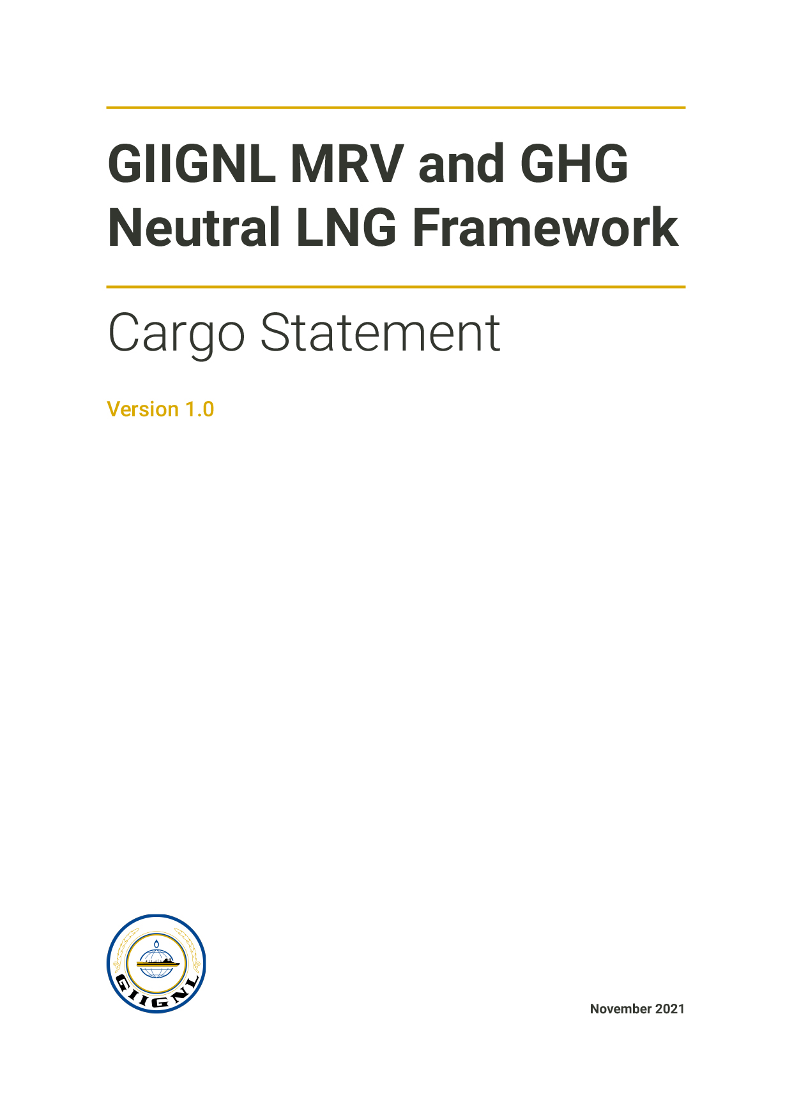
Contents
Cargo Statement 1
Details of Reporter and LNG Cargo 1
LNG Life Cycle Stages Included in the GHG Footprint 2
GHG Emissions Statement 3
Standards Applied 4
Stage-based GHG data and information 5
Stage-based Calculation Approach 7
Low GHG Emission Features 8
GHG Offsets 9
GHG Offset Statement 9
Details of Offset Projects Used 9
GHG Offset Strategy 10
GHG Emissions Reduction Plan 11
Reduction Plan 11
Emission Reduction Performance 12
Stage Based Offsets (if separately provided by Stage owner and used in a GHG Footprint) 14
GHG Neutrality 15
Conformity Assessment of the Statement 16
Annex 1: 17
Declarations provided for under the GIIGNL MRV and GHG Neutral Framework 17

The content set out in this form is intended to support users of the GIIGNL MRV and GHG Neutral Framework.
The content set out in this Cargo Statement may be presented by the Reporter in other equivalent formats if appropriate.

Cargo Statement

Details of Reporter and LNG Cargo
Required for ALL declarations*

Statement Date | Click or tap to enter a date.
Reporting Entity/Entities | Click or tap here to enter text.

LNG Cargo Details
Buyer | Click or tap here to enter text. | ☐ N/A  (Stage Statement only)
Seller | Click or tap here to enter text.
Load Port | Click or tap here to enter text.
Loading Date | Click or tap to enter a date.
Discharge Port | Click or tap here to enter text.
Discharge Date | Click or tap to enter a date.
Cargo quantity discharged AND units (energy, HHV) | Click or tap here to enter text.
Ship (Name / IMO number) | Click or tap here to enter text.

 | Declaration Category (tick one) * |  | Sections
 | Stage Statement | ☐ | 1- 7
Cargo Statement | GHG Footprint | ☐ | 1- 7
 | GHG Offset | ☐ | 1- 7
 | GHG Offset with Reduction Plan | ☐ | 1- 7
 | GHG Neutral | ☐ | 1- 7
*See Annex 1 for description of Declaration Categories

The signatories below confirm that this Statement has been prepared in alignment with the GIIGNL MRV and GHG Neutral Framework and applicable standards and methodologies as described in this statement.

Verification Status:
Verified ☐ by Click or tap here to enter text. (attach verification statement).
Verification pending ☐ Planned verification date Click or tap here to enter text.

Signed Click or tap here to enter text.
For Click or tap here to enter text.

Signed Click or tap here to enter text.
For Click or tap here to enter text.

LNG Life Cycle Stages Included in the GHG Footprint
Required for ALL declarations*

Stages of the LNG life cycle that are included in the information and data presented in this Declaration.

Stage | Stage Included
Drilling (production and infill) | ☐
Production | ☐
Gathering, boosting and processing | ☐
Gas transport | ☐
LNG production and loading | ☐
Shipping | ☐
Unloading, storage and Regasification | ☐
Gas Transmission | ☐
Gas Storage | ☐
Gas Distribution | ☐
End use | ☐
Other: Click or tap here to enter text. | ☐
Other: Click or tap here to enter text. | ☐

Notes
Click or tap here to enter text.

GHG Emissions Statement
Required for ALL declarations*

 | Value | Unit
HHV Energy content (as basis for emissions report) | Click or tap here to enter text. | mmBtu  ☐ | MJ  ☐
GHG emissions | Click or tap here to enter text. | tCO₂e
GHG Intensity | Click or tap here to enter text. | kgCO₂e/mmBtu  ☐ | kgCO₂e/MJ  ☐
Methane emissions | Click or tap here to enter text. | tCH₄
Methane Intensity | Click or tap here to enter text. | kgCH₄/mmBtu  ☐ | kgCH₄/MJ  ☐
GHG offset retirement | Click or tap here to enter text. | tCO₂e

Greenhouse gases included in the carbon dioxide equivalent (CO₂e) value:

Carbon Dioxide ☐ | Methane ☐ | N₂O ☐ | Other ☐ Click or tap here to enter text.

Standards Applied
Required for ALL declarations*
State below the reference standards used for developing the GHG footprint and (if applicable) making a claim of GHG neutrality.
 | Standards Applied (see Framework Step B)
Stage Statement | Click or tap here to enter text.
GHG Footprint
GHG Offset LNG Cargo | Click or tap here to enter text.
GHG Offset LNG Cargo
with Reduction Plan
GHG Neutral LNG Cargo

Notes
Click or tap here to enter text.

Stage-based GHG data and information
Required for ALL declarations*

Stage | Stage Included | Export Energy Content  Energy unit: Click or tap here to enter text. | Stage Emissions (tCO₂e) * | Intensity  (tCO₂e/ energy unit) ** | Methane Intensity (tCH₄/ energy unit) ** | Separately Verified ***
Drilling  (production and infill) | Choose an item. | Click or tap here to enter text. | Click or tap here to enter text. | Click or tap here to enter text. | Click or tap here to enter text. | Choose an item.
Production | Choose an item. | Click or tap here to enter text. | Click or tap here to enter text. | Click or tap here to enter text. | Click or tap here to enter text. | Choose an item.
Gathering, boosting and processing | Choose an item. | Click or tap here to enter text. | Click or tap here to enter text. | Click or tap here to enter text. | Click or tap here to enter text. | Choose an item.
Gas transport | Choose an item. | Click or tap here to enter text. | Click or tap here to enter text. | Click or tap here to enter text. | Click or tap here to enter text. | Choose an item.
LNG production and loading | Choose an item. | Click or tap here to enter text. | Click or tap here to enter text. | Click or tap here to enter text. | Click or tap here to enter text. | Choose an item.
Shipping | Choose an item. | Click or tap here to enter text. | Click or tap here to enter text. | Click or tap here to enter text. | Click or tap here to enter text. | Choose an item.
Unloading, storage and Regasification | Choose an item. | Click or tap here to enter text. | Click or tap here to enter text. | Click or tap here to enter text. | Click or tap here to enter text. | Choose an item.
Gas Transmission | Choose an item. | Click or tap here to enter text. | Click or tap here to enter text. | Click or tap here to enter text. | Click or tap here to enter text. | Choose an item.
Gas Storage | Choose an item. | Click or tap here to enter text. | Click or tap here to enter text. | Click or tap here to enter text. | Click or tap here to enter text. | Choose an item.
Gas Distribution | Choose an item. | Click or tap here to enter text. | Click or tap here to enter text. | Click or tap here to enter text. | Click or tap here to enter text. | Choose an item.
End use | Choose an item. | Click or tap here to enter text. | Click or tap here to enter text. | Click or tap here to enter text. | Click or tap here to enter text. | Choose an item.
Other: Click or tap here to enter text. | Choose an item. | Click or tap here to enter text. | Click or tap here to enter text. | Click or tap here to enter text. | Click or tap here to enter text. | Choose an item.
Other: Click or tap here to enter text. | Choose an item. | Click or tap here to enter text. | Click or tap here to enter text. | Click or tap here to enter text. | Click or tap here to enter text. | Choose an item.

*Stages may be aggregated as appropriate to align with reporting structure. Enter data in the last stage and note this clearly
**Ensure all units are clearly stated
***If individual lifecycle stages have been verified, ensure verification statements and supporting information are made available to the Statement Verifier (see section 10).

Notes
Click or tap here to enter text.

Stage-based Calculation Approach
Stage | Stage Included | Estimate % emissions based on primary data | Overview of calculation methodology(ies) applied, including use of primary and/or secondary data (attach separate methodology description(s) as appropriate) | Date range of the emissions calculation | GWP Applied  (e.g. AR5/AR6)
Drilling  (production and infill) | ☐ | Choose an item. | Click or tap here to enter text. | Click or tap here to enter text. | Choose an item.
Production | ☐ | Choose an item. | Click or tap here to enter text. | Click or tap here to enter text. | Choose an item.
Gathering, boosting and processing | ☐ | Choose an item. | Click or tap here to enter text. | Click or tap here to enter text. | Choose an item.
Gas transport | ☐ | Choose an item. | Click or tap here to enter text. | Click or tap here to enter text. | Choose an item.
LNG production and loading | ☐ | Choose an item. | Click or tap here to enter text. | Click or tap here to enter text. | Choose an item.
Shipping | ☐ | Choose an item. | Include shipping boundary, including start point of ballast and other relevant criteria such as trans-shipments  Click or tap here to enter text. | Click or tap here to enter text. | Choose an item.
Unloading, storage and Regasification | ☐ | Choose an item. | Click or tap here to enter text. | Click or tap here to enter text. | Choose an item.
Gas Transmission | ☐ | Choose an item. | Click or tap here to enter text. | Click or tap here to enter text. | Choose an item.
Gas Storage | ☐ | Choose an item. | Click or tap here to enter text. | Click or tap here to enter text. | Choose an item.
Gas Distribution | ☐ | Choose an item. | Click or tap here to enter text. | Click or tap here to enter text. | Choose an item.
End use | ☐ | Choose an item. | Click or tap here to enter text. | Click or tap here to enter text. | Choose an item.
Other: Click or tap here to enter text. | ☐ | Choose an item. | Click or tap here to enter text. | Click or tap here to enter text. | Choose an item.
Other: Click or tap here to enter text. | ☐ | Choose an item. | Click or tap here to enter text. | Click or tap here to enter text. | Choose an item.

Notes
Click or tap here to enter text.

Low GHG Emission Features
Required for ALL declarations*

Stage | Characteristics of the GHG Footprint that represent ‘low GHG emissions’. (e.g. low CO₂ fields, flare elimination, carbon capture; e-Drive; etc. (see section E of the GIIGNL MRV and GHG Neutral Framework).  Include reference criteria used in the determination of ‘low GHG emissions’.
Drilling (production and infill) | Click or tap here to enter text.
Production | Click or tap here to enter text.
Gathering, boosting and processing | Click or tap here to enter text.
Gas transport | Click or tap here to enter text.
LNG production and loading | Click or tap here to enter text.
Shipping | Click or tap here to enter text.
Unloading, storage and Regasification | Click or tap here to enter text.
Gas Transmission | Click or tap here to enter text.
Gas Storage | Click or tap here to enter text.
Gas Distribution | Click or tap here to enter text.
End use | Click or tap here to enter text.
Other: Click or tap here to enter text. | Click or tap here to enter text.
Other: Click or tap here to enter text. | Click or tap here to enter text.

Notes
Click or tap here to enter text.

GHG Offsets
Required for GHG Offset, GHG offset with Reduction Plan and GHG Neutral declarations
Optional for Stage Statements

GHG Offset Statement
 | Value | Unit
GHG emissions declared in this Cargo Statement |  | tCO₂e
Carbon offset retirement |  | tCO₂e

Details of Offset Projects Used
Project Title | Offset Type  (e.g., Renewable energy, Nature based removal) | Registry  (e.g., VCS, CAR, Gold Standard) | Certificate numbers* | Retirement date | GIIGNL Framework aligned? | Quantity (tCO₂e)
Click or tap here to enter text. | Click or tap here to enter text. | Click or tap here to enter text. | Click or tap here to enter text. | Click or tap to enter a date. | Choose an item. | Click or tap here to enter text.
Click or tap here to enter text. | Click or tap here to enter text. | Click or tap here to enter text. | Click or tap here to enter text. | Click or tap to enter a date. | Choose an item. | Click or tap here to enter text.
Click or tap here to enter text. | Click or tap here to enter text. | Click or tap here to enter text. | Click or tap here to enter text. | Click or tap to enter a date. | Choose an item. | Click or tap here to enter text.
Click or tap here to enter text. | Click or tap here to enter text. | Click or tap here to enter text. | Click or tap here to enter text. | Click or tap to enter a date. | Choose an item. | Click or tap here to enter text.
TOTAL |  |  |  |  |  | Click or tap here to enter text.

*Attach retirement certificate or provide link to retirement evidence.

GHG Offset Strategy
Confirm that the offsets used are in line with the Reporter’s Offset Strategy and provide overview here
Click or tap here to enter text.

GHG Emissions Reduction Plan
Required for GHG offset with Reduction Plan and GHG Neutral declarations*
Optional for Stage Statements

Provide an overview of the planned measures for reducing emissions within the GHG footprint. Attach a separate GHG reduction plan if applicable.
Note that the plan does not need to address every stage, but please indicate the stage(s) that are subject to planned positive actions.

Reduction Plan
Stage | Included? | Description of GHG emissions reduction plans associated with the cargo.  Stages may be grouped and/or consolidated and reference to separate documentation may be made
Drilling (production and infill) | ☐ | Click or tap here to enter text.
Production | ☐ | Click or tap here to enter text.
Gathering, boosting and processing | ☐ | Click or tap here to enter text.
Gas transport | ☐ | Click or tap here to enter text.
LNG production and loading | ☐ | Click or tap here to enter text.
Shipping | ☐ | Click or tap here to enter text.
Unloading, storage and Regasification | ☐ | Click or tap here to enter text.
Gas Transmission | ☐ | Click or tap here to enter text.
Gas Storage | ☐ | Click or tap here to enter text.
Gas Distribution | ☐ | Click or tap here to enter text.
End use | ☐ | Click or tap here to enter text.
Other: Click or tap here to enter text. | ☐ | Click or tap here to enter text.
Other: Click or tap here to enter text. | ☐ | Click or tap here to enter text.

Emission Reduction Performance
 | CO2e intensity  (kgCO2e/mmBtu) |  |  | CH4 intensity  (kgCH4/mmBtu)
 | Actual | Baseline | Target  (if applicable) | Actual | Baseline | Target  (if applicable)
Consolidated Cargo Footprint Intensity | Click or tap here to enter text. | Click or tap here to enter text. | Click or tap here to enter text. | Click or tap here to enter text. | Click or tap here to enter text. | Click or tap here to enter text.

Stage based (if applicable)
Drilling (production and infill) | Click or tap here to enter text. | Click or tap here to enter text. | Click or tap here to enter text. | Click or tap here to enter text. | Click or tap here to enter text. | Click or tap here to enter text.
Production | Click or tap here to enter text. | Click or tap here to enter text. | Click or tap here to enter text. | Click or tap here to enter text. | Click or tap here to enter text. | Click or tap here to enter text.
Gathering, boosting and processing | Click or tap here to enter text. | Click or tap here to enter text. | Click or tap here to enter text. | Click or tap here to enter text. | Click or tap here to enter text. | Click or tap here to enter text.
Gas transport | Click or tap here to enter text. | Click or tap here to enter text. | Click or tap here to enter text. | Click or tap here to enter text. | Click or tap here to enter text. | Click or tap here to enter text.
LNG production and loading | Click or tap here to enter text. | Click or tap here to enter text. | Click or tap here to enter text. | Click or tap here to enter text. | Click or tap here to enter text. | Click or tap here to enter text.
Shipping | Click or tap here to enter text. | Click or tap here to enter text. | Click or tap here to enter text. | Click or tap here to enter text. | Click or tap here to enter text. | Click or tap here to enter text.
Unloading, storage and Regasification | Click or tap here to enter text. | Click or tap here to enter text. | Click or tap here to enter text. | Click or tap here to enter text. | Click or tap here to enter text. | Click or tap here to enter text.
Gas Transmission | Click or tap here to enter text. | Click or tap here to enter text. | Click or tap here to enter text. | Click or tap here to enter text. | Click or tap here to enter text. | Click or tap here to enter text.
Gas Storage | Click or tap here to enter text. | Click or tap here to enter text. | Click or tap here to enter text. | Click or tap here to enter text. | Click or tap here to enter text. | Click or tap here to enter text.
Gas Distribution | Click or tap here to enter text. | Click or tap here to enter text. | Click or tap here to enter text. | Click or tap here to enter text. | Click or tap here to enter text. | Click or tap here to enter text.
End use | Click or tap here to enter text. | Click or tap here to enter text. | Click or tap here to enter text. | Click or tap here to enter text. | Click or tap here to enter text. | Click or tap here to enter text.
Other: Click or tap here to enter text. | Click or tap here to enter text. | Click or tap here to enter text. | Click or tap here to enter text. | Click or tap here to enter text. | Click or tap here to enter text. | Click or tap here to enter text.
Other: Click or tap here to enter text. | Click or tap here to enter text. | Click or tap here to enter text. | Click or tap here to enter text. | Click or tap here to enter text. | Click or tap here to enter text. | Click or tap here to enter text.

Overview of GHG Emission Reduction Plan and Performance
Click or tap here to enter text.

Stage Based Offsets (if separately provided by Stage owner and used in a GHG Footprint)
Stage | Stage based offsets included (tCO₂e) | Offset project title | Registry  (e.g., VCS, CAR, Gold Standard)
Drilling (production and infill) | Click or tap here to enter text. | Click or tap here to enter text. | Click or tap here to enter text.
Production | Click or tap here to enter text. | Click or tap here to enter text. | Click or tap here to enter text.
Gathering, boosting and processing | Click or tap here to enter text. | Click or tap here to enter text. | Click or tap here to enter text.
Gas transport | Click or tap here to enter text. | Click or tap here to enter text. | Click or tap here to enter text.
LNG production and loading | Click or tap here to enter text. | Click or tap here to enter text. | Click or tap here to enter text.
Shipping | Click or tap here to enter text. | Click or tap here to enter text. | Click or tap here to enter text.
Unloading, storage and Regasification | Click or tap here to enter text. | Click or tap here to enter text. | Click or tap here to enter text.
Gas Transmission | Click or tap here to enter text. | Click or tap here to enter text. | Click or tap here to enter text.
Gas Storage | Click or tap here to enter text. | Click or tap here to enter text. | Click or tap here to enter text.
Gas Distribution | Click or tap here to enter text. | Click or tap here to enter text. | Click or tap here to enter text.
End use | Click or tap here to enter text. | Click or tap here to enter text. | Click or tap here to enter text.
Other: Click or tap here to enter text. | Click or tap here to enter text. | Click or tap here to enter text. | Click or tap here to enter text.
Other: Click or tap here to enter text. | Click or tap here to enter text. | Click or tap here to enter text. | Click or tap here to enter text.

GHG Neutrality
Required for GHG Neutral declarations*

Commitment to long term decarbonisation and maintenance of GHG Neutrality Yes ☐
Full life cycle included from well to end use? Yes ☐
Conformance with all criteria set out in the GIIGNL MRV and GHG Neutral Framework? Yes ☐
Conformance with PAS 2060 (or equivalent)? Yes ☐
PAS 2060 Qualifying Explanatory Statement (QES) attached Yes ☐

Notes
Click or tap here to enter text.

Conformity Assessment of the Statement
Required for ALL declarations*

Verification completed Yes ☐
No ☐

If no, state planned verification date Click or tap to enter a date.

All information presented in this Stage/Cargo Statement forms the assertion to be assessed by the verifier and reported in the Verification Opinion.
Date verification undertaken | Click or tap to enter a date.
Entity responsible for the verification | Click or tap here to enter text.
Scope and boundary of the assessment | Click or tap here to enter text.
Level of Assurance applied | Click or tap here to enter text.

Has the verifier relied on 3rd party verification of Stage Statements or other component parts of the GHG Footprint?* | Choose an item.
*Not applicable for Stage Statements
Verification report attached to this Declaration Yes ☐

Annex 1:

Declarations provided for under the GIIGNL MRV and GHG Neutral Framework
The declarations supported by this Framework are:
A ‘ Stage Statement’ (relating to a stage or sub set of stages in the life cycle that are used in the calculation of a Cargo footprint):
- ‘GIIGNL Framework Aligned Stage Statement’: a verified statement of GHG intensity and emissions calculated in accordance with a defined GHG footprint standard (e.g. ISO 14067:2019) and the criteria set out in this Framework.
A GHG Footprint for a product is built from the emissions associated with each stage included in the life cycle boundary. Provision has therefore been made for operators of stages within the LNG life cycle to issue a verified ‘Stage Statement’ that can be used in the calculation of the Cargo GHG Footprint, thereby increasing the contribution of primary, stage-specific data. Stage Statements from 3rd parties are not a required component of the Framework, but it is anticipated that their use will increase over time.
A ‘Cargo Statement’ (relating to a delivered LNG Cargo):
- ‘GIIGNL Framework Aligned LNG Cargo GHG Footprint’: a verified full (‘cradle to grave’) or partial (‘cradle to gate’) life cycle GHG footprint calculated in accordance with a defined GHG footprint standard (e.g. ISO 14067:2019) and the criteria set out in this Framework.
- ‘GIIGNL Framework Aligned GHG Offset LNG Cargo’: a verified full or partial life cycle GHG footprint that has been offset with carbon credits that meet the criteria set out in the Framework.
- ‘GIIGNL Framework Aligned GHG Offset LNG Cargo with Reduction Plan’: a verified full or partial life cycle GHG footprint that embodies an emission reduction plan and has been offset with carbon credits that meet the criteria set out in the Framework.
- ‘GIIGNL Framework Aligned GHG Neutral LNG Cargo’: a verified full life cycle GHG footprint that embodies an emission reduction plan and commitment to long term decarbonisation, has been offset with carbon credits that meet the criteria set out in the Framework and is verified to conform to an internationally accepted carbon neutral standard (PAS 2060 or equivalent).
There are FIVE available Declaration Pathways. This approach is illustrated in Figure 1 below and is reflected in the overall design of the Framework and the associated declarations.
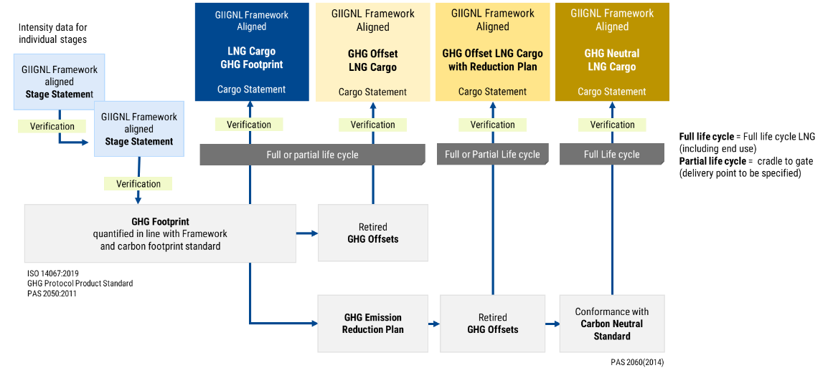
Figure 1: Declarations provided for under the Framework

